**PROJECT REPORT**

for

Open Source Programming (ITE-1008)

**“10DER.com: A PHP-based tender management portal”**

By

**R SENTHIL KUMAR** (Registration number: **18BIT0048**)

On behalf of the team:

|  |  |
| --- | --- |
| Name | Register Number |
| R Senthil Kumar | 18BIT0048 |
| Shashank Kesharwani | 18BIT0050 |
| Gunjan Kumar | 18BIT0070 |

**Name of the faculty : Subashanthini S**

SLOT : B1+TB1

WINTER 2019 -2020



**Abstract**

Tenders are a part-and-parcel of demand-supply fields where there are multiple competitors to provide a service for a demand placed by government/ private organisations. In the initial days, Tenders were sanctioned based on in-paper bids. Now, for government tenders, a standard website has been launched by the Government of India, but it lacks several features, and is hence “less-user-friendly”. Also, there is no unified portal for launching tenders and bids for private-group deals.

Hence, our aim is:-

“*To create a website that can manage creating, launching and sanctioning of government and individual tenders, while simultaneously allowing users to place bids to provide services for the same.”*

We use PHP as the base of the website 10DER.com, along with sufficient usage of HTML, CSS, JS and JQuery for UI/UX features. We also use MySQL (via PhpMyAdmin) as an integrated one-point-database that satisfies all DB-related goals. Server is fired up in localhost by Apache (via XAMPP).

**List of PHP features included**

Since PHP is the base of the idea of the 10DER.com, we will exploit the features that PHP provides. The features that 10DER.com use are enlisted below, along with their respective functionalities:-

1. **Sessions**

Sessions are the backbone for most of the full-stack websites. In our website 10DER.com, we need sessions to store the active-status of users who are logged in. **$_SESSION[‘user’]**is the most frequently used session variable, and is used to give an idea to the client system that a service provider/service requester has already logged in. This variable will come into picture when the client performs cross-navigation/page-to-page shifting/general surfing across the 10DER.com domain.

1. **Cookies**

Cookies are chunks of data stored in the client system. We use two cookies here, **$_COOKIE[‘user’]**and **$_COOKIE[‘category’]**. Both these cookies are set in **login.php** and unset in **logout.php .**The purpose of these cookies is to maintain a record of the name, and type of active user present in the local system

1. **REGular EXpressions**

REGEX is helpful in many areas of website development, from URL obtainment to Form validation. We use Regular Expressions in **login.php**, specifically for Sign Up Form Validation. Email, mobile and name fields are validated using the patterns provided in appropriate methods, using regular expression match functions.

1. **File Handling**

File handling is the concept of mining data present in the hosting system’s file and making use of it in the launched website. In our website 10DER.com, we use file handling to obtain “area-of-interest” field values of the 10DER-bidder system. Fields of interest are constantly changing, hence it is highly erroneous to hard-code the fields into the server. Methods like **readfile()**and **fclose()** are used now-and-then to get field-values and load it into the 10DER system.

1. **Password encryption**

Storing password directly into the database might evoke several security issues, and hence create hassles for our 10DER.com website, where security is our top priority. Hence, passwords are encrypted so that the DB only has the encrypted values. PHP Functions like **password_verify()**and **password_hash()** are used to hash-encode the passwords.

**Structure of the database table and fields**

Database acts as the repository for any data-manipulation-website. We use PhpMyAdmin, a MySQL web-GUI software provided by XAMPP. The Entity-Relationship diagram is shown below, followed by table structures:

**ENTITY-RELATIONSHIP DIAGRAM:**

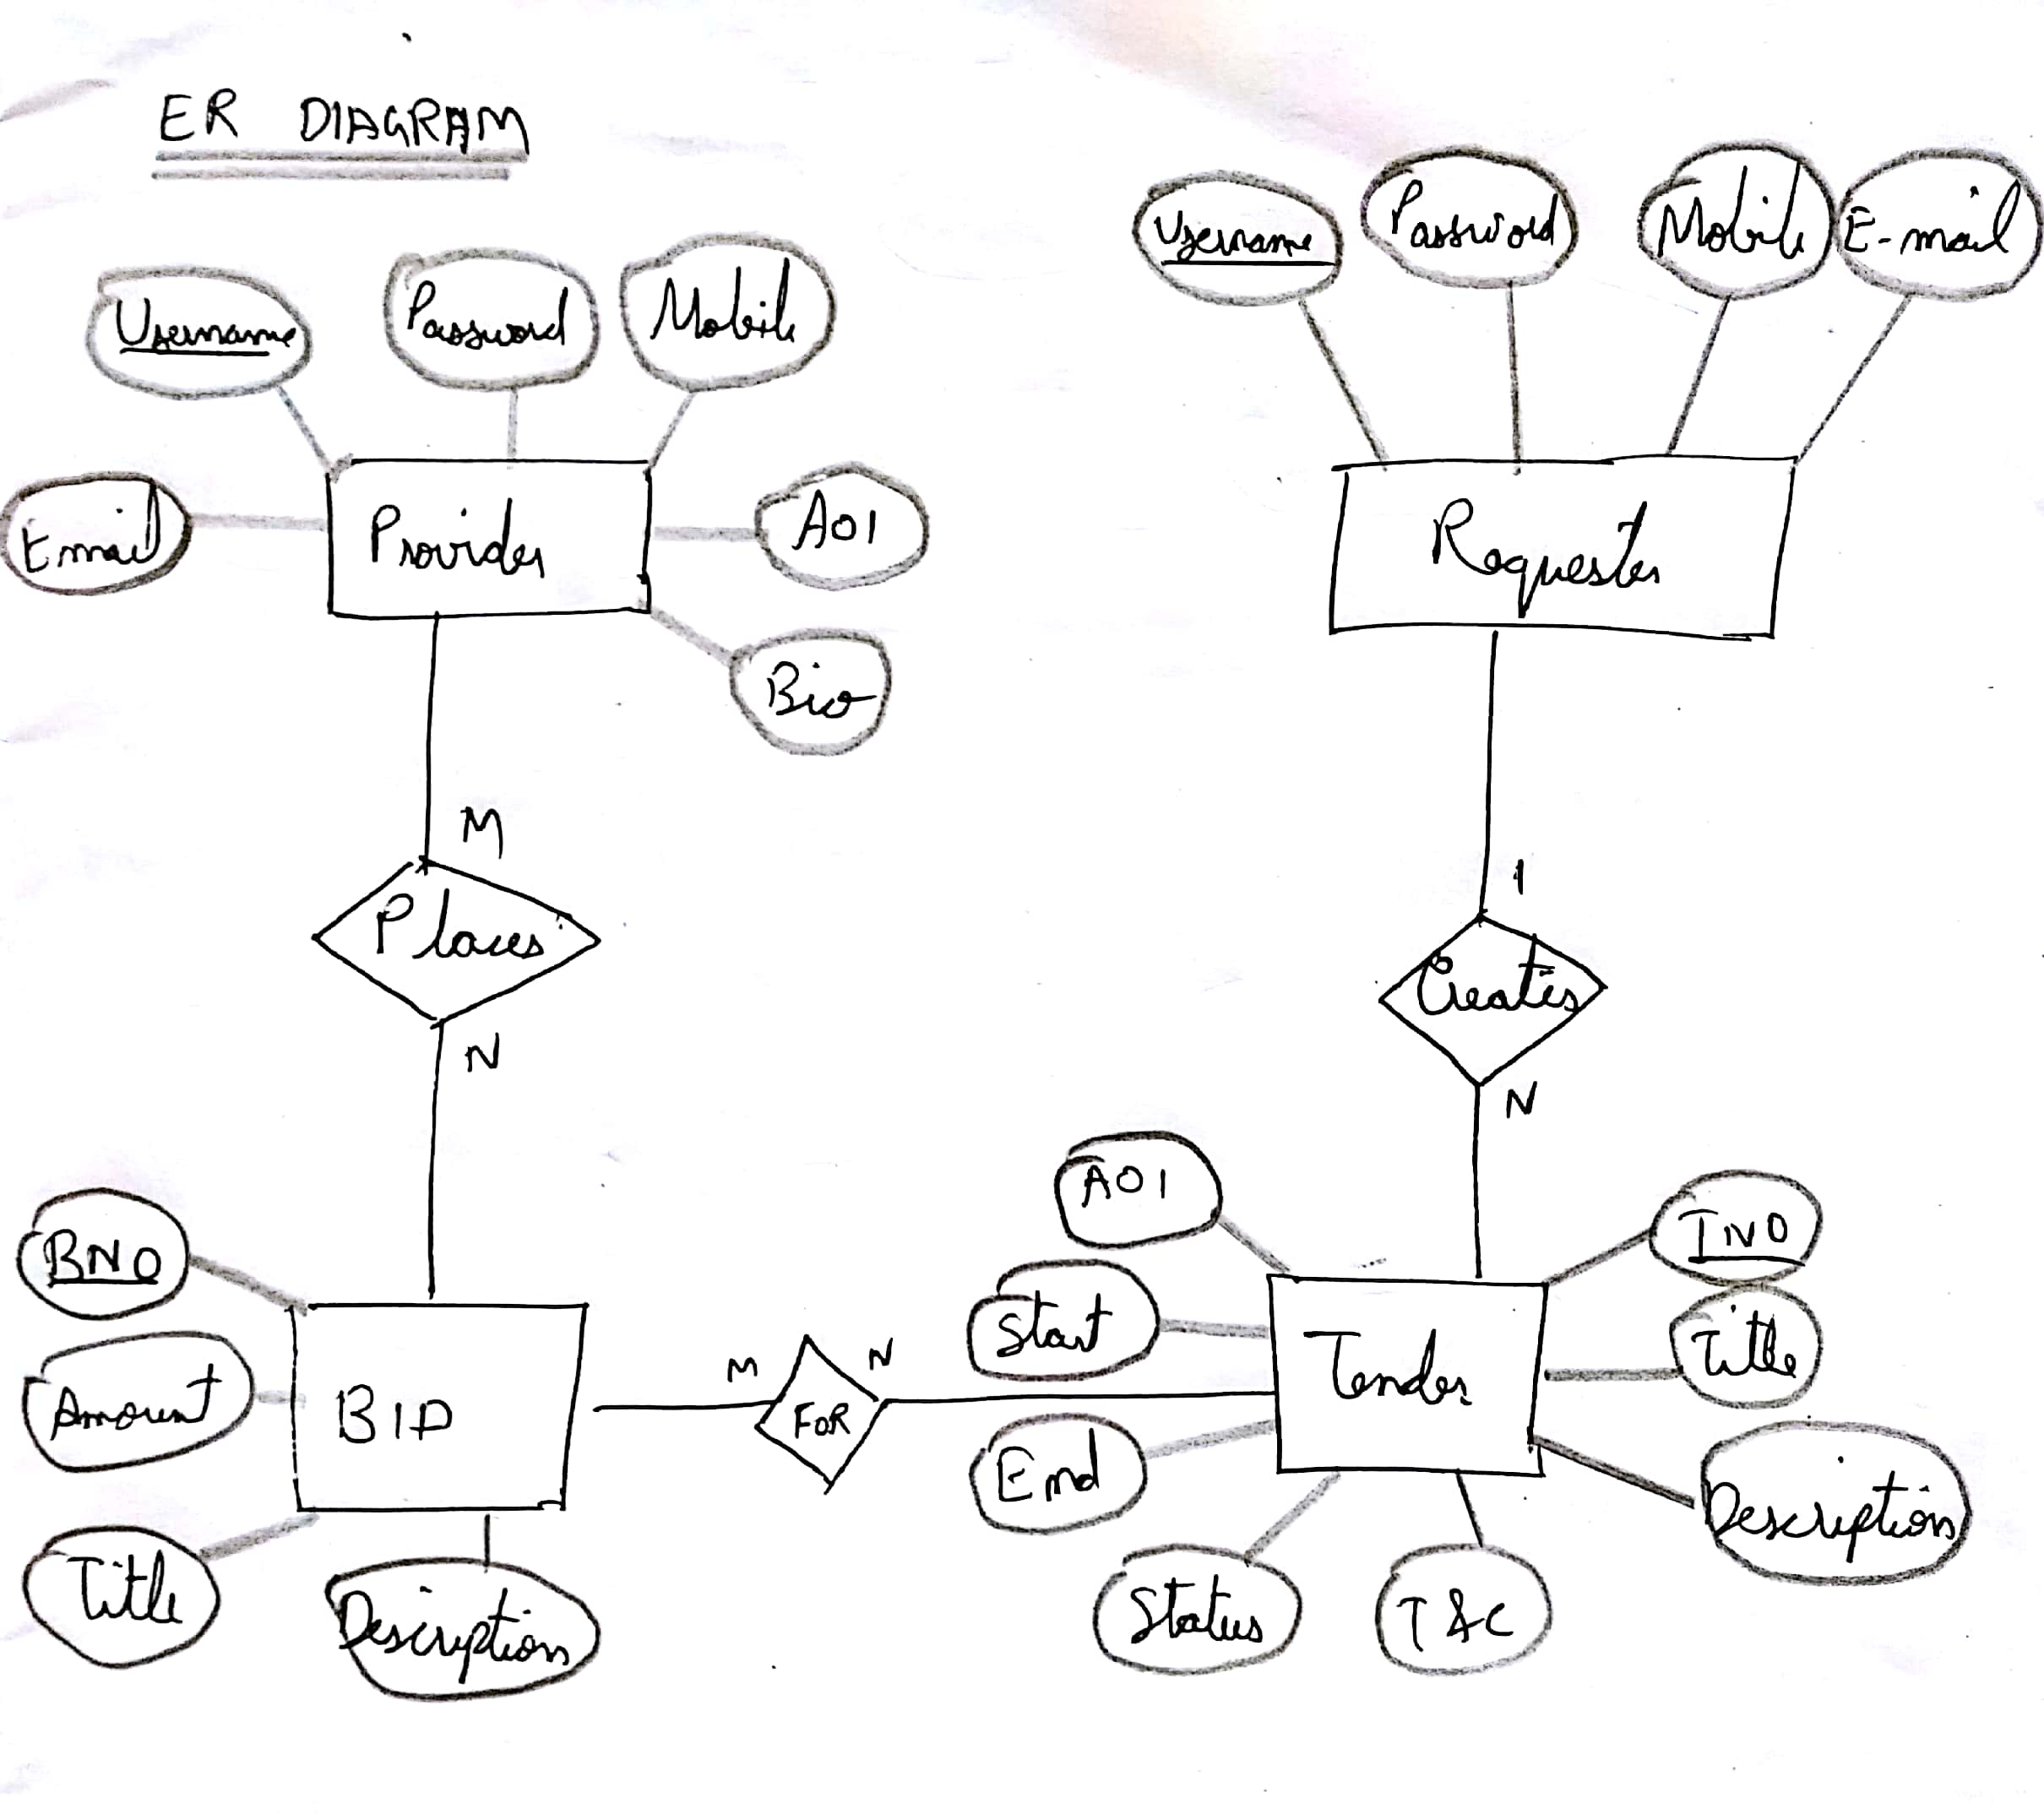

*Figure 1:E-R Diagram with 4 Entities for 10DER.com website*

**SERVER DATABASE TABLES:**

***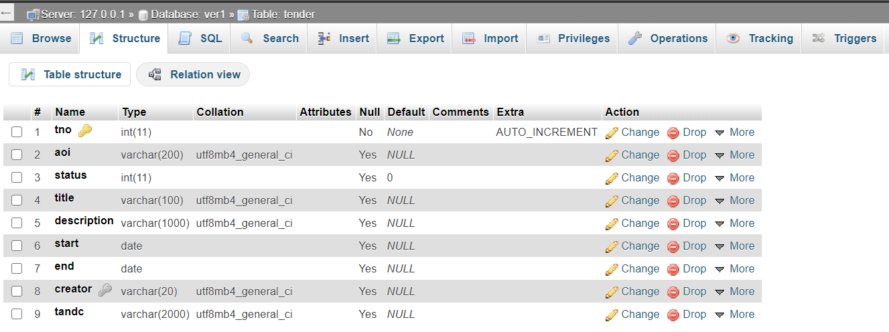****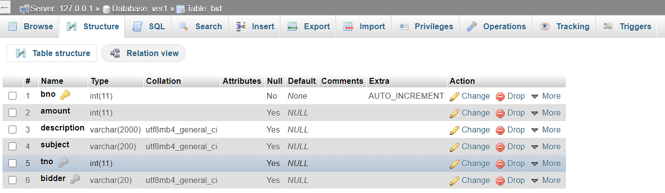*

*Figure 2: Tender table structure, Figure 3: Bid table structure*

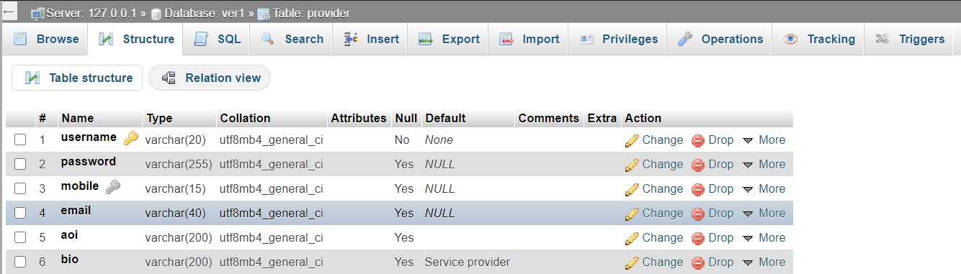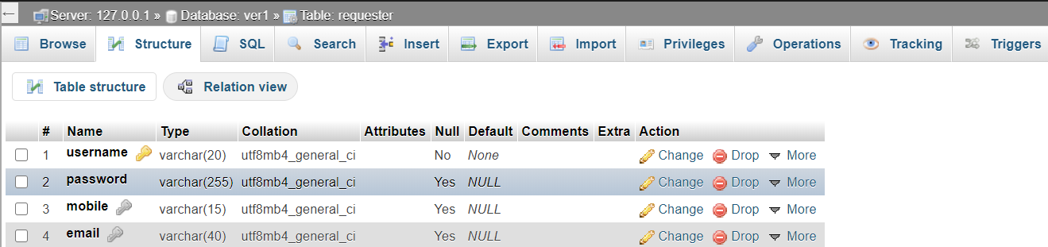

*Figure 4:Provider table structure, Figure 5:Requester table structure*

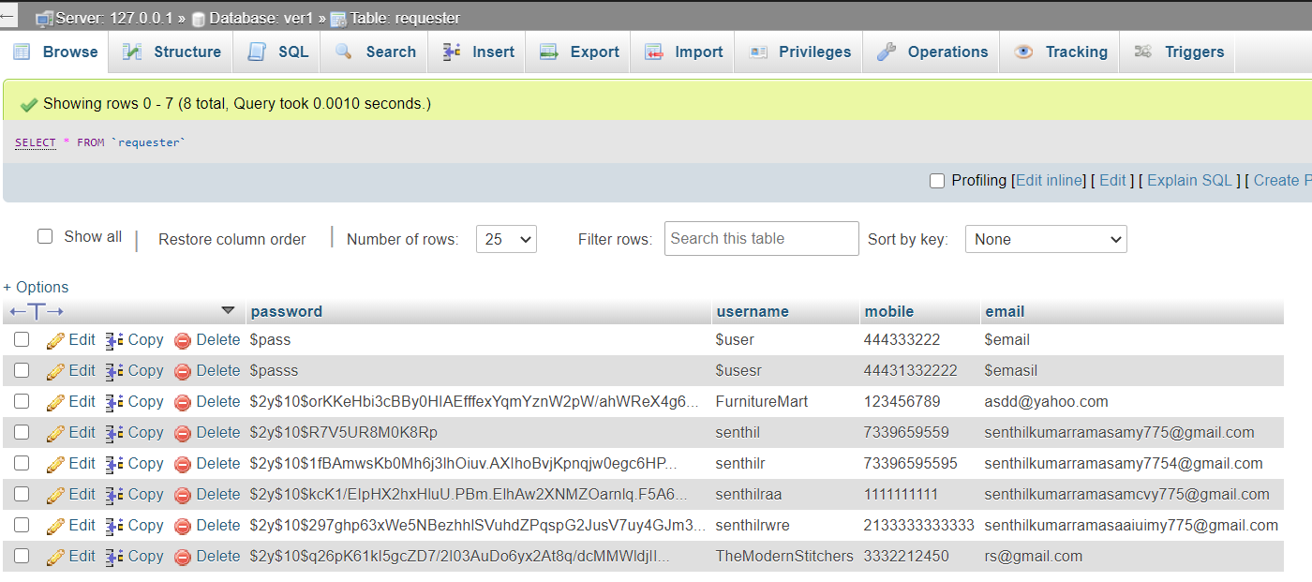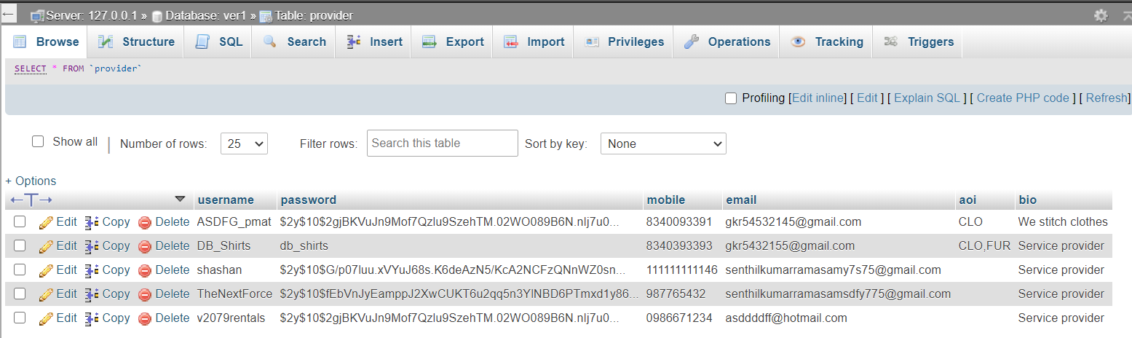

*Figure 6:Requester table record fields, Figure 7:Provider table record fields (note that password is stored in encrypted format)*

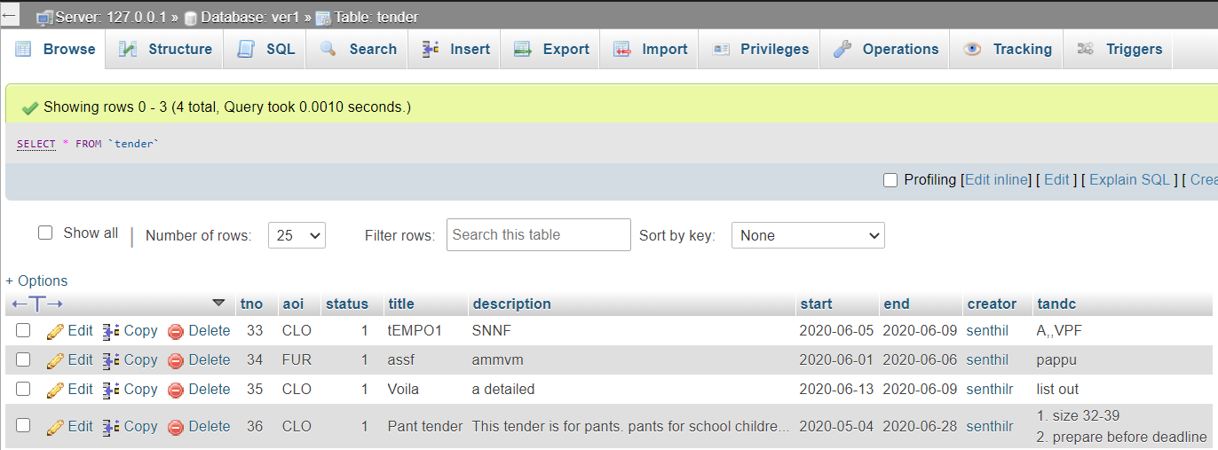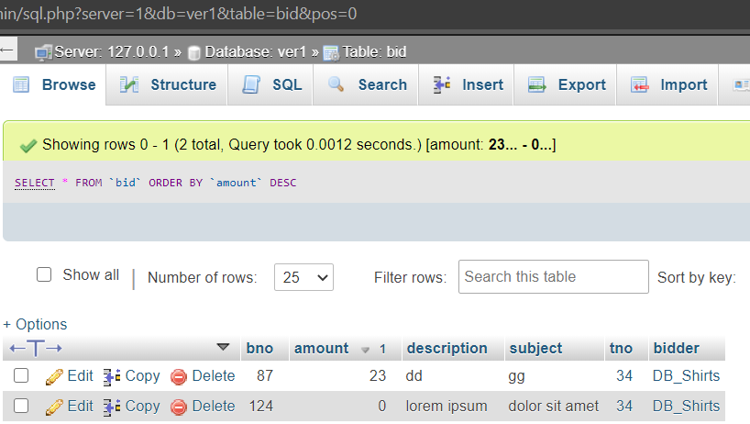

*Figure 8: Tender table fields, Figure 9: Bid table fields*

**Output screenshots**

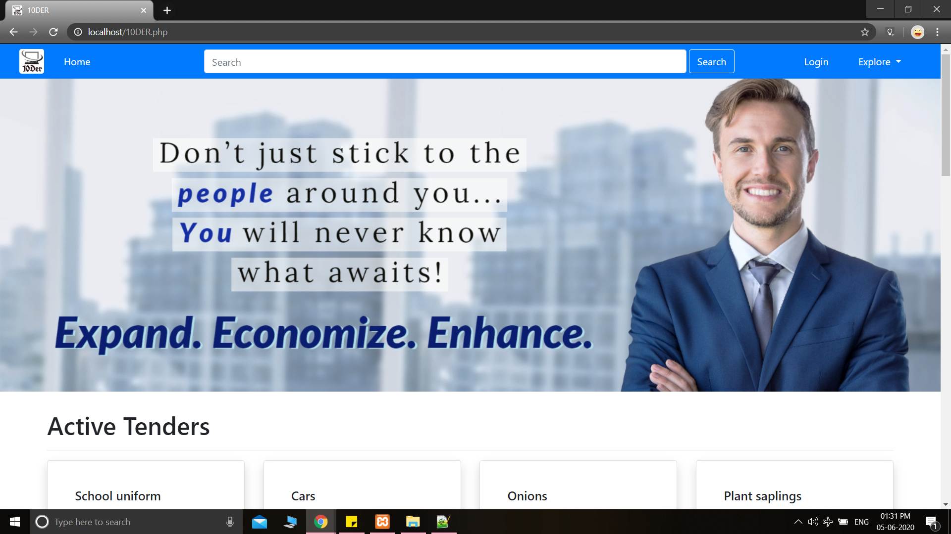

*Figure 10: Landing page*

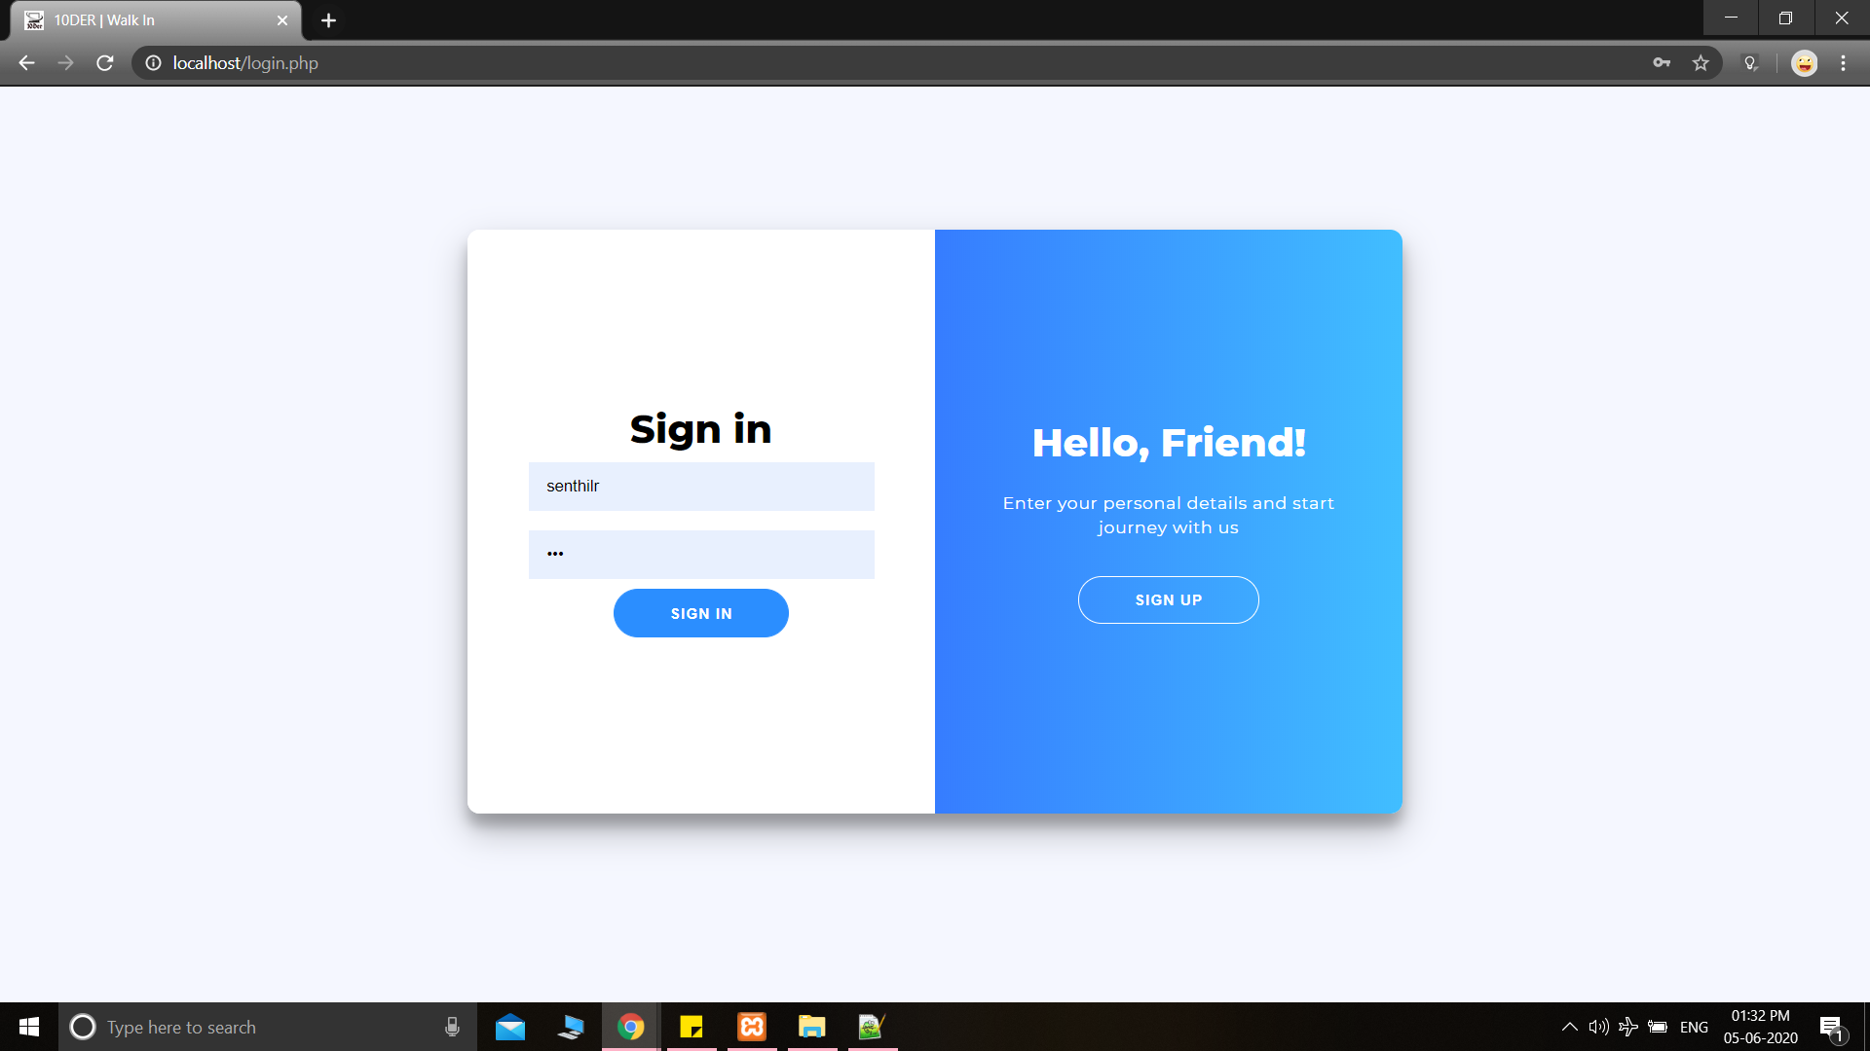

*Figure 11: Login page*

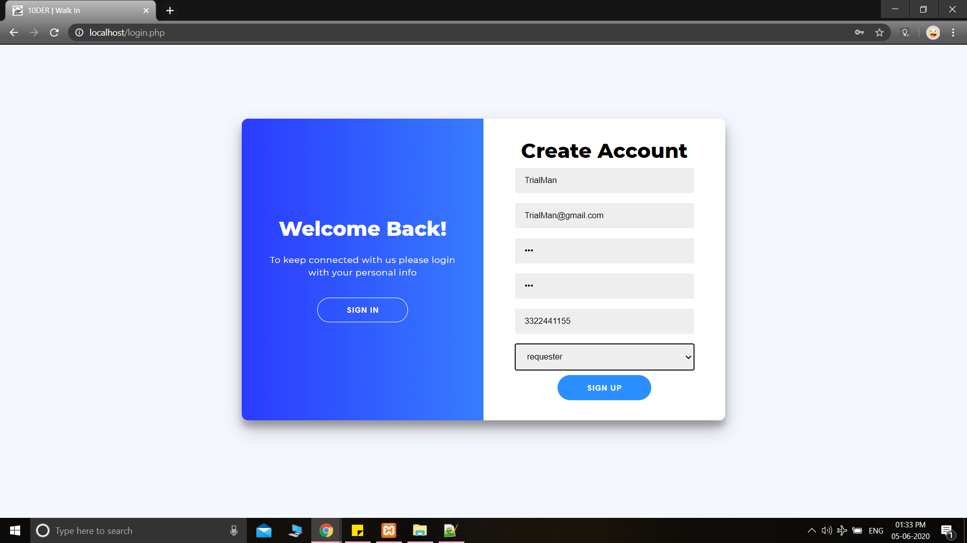

*Figure 12: Sign Up panel with submit values*

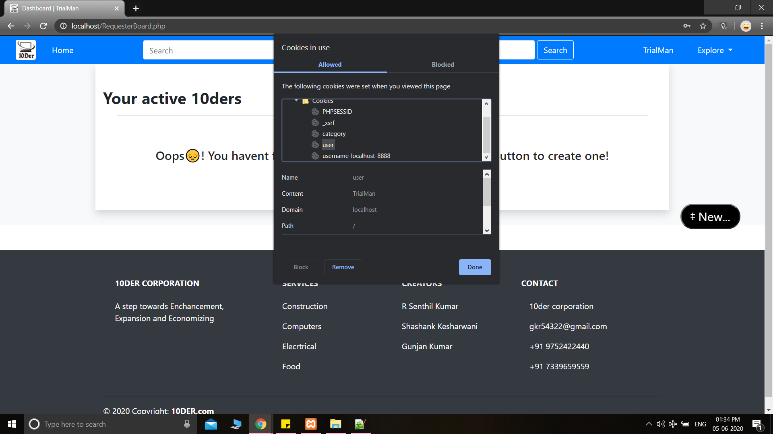

*Figure 13: Requester’s dashboard page with cookie values*

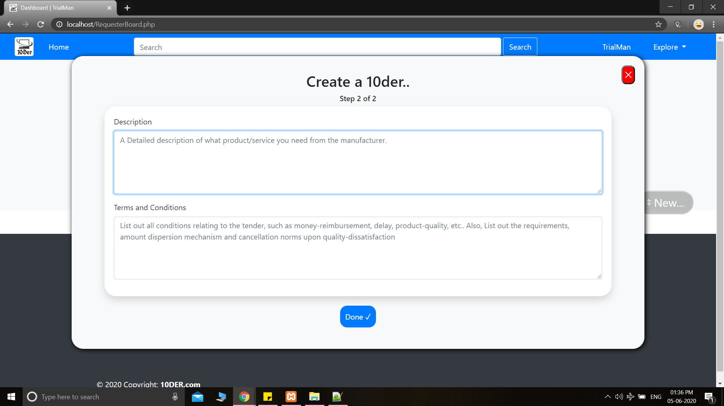

*Figure 14: Create tender pop-up*

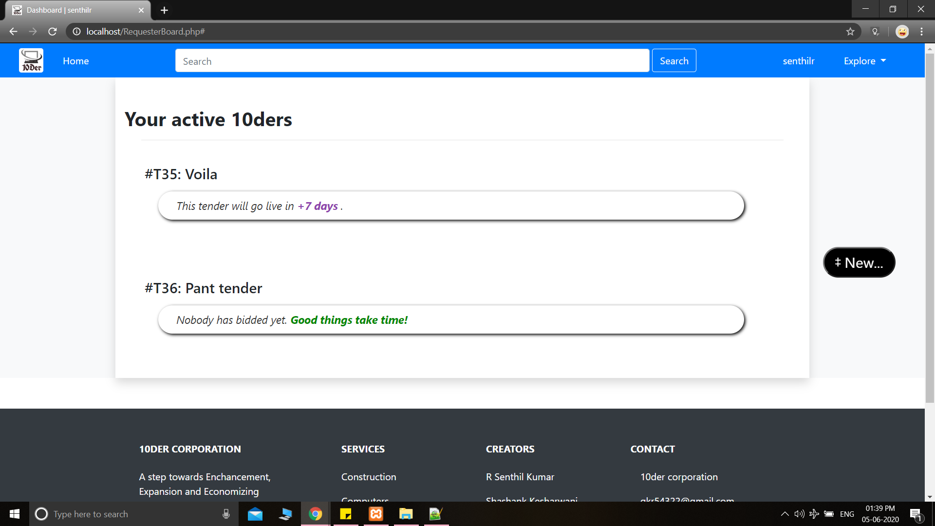

*Figure 15: Dashboard after creating tenders*

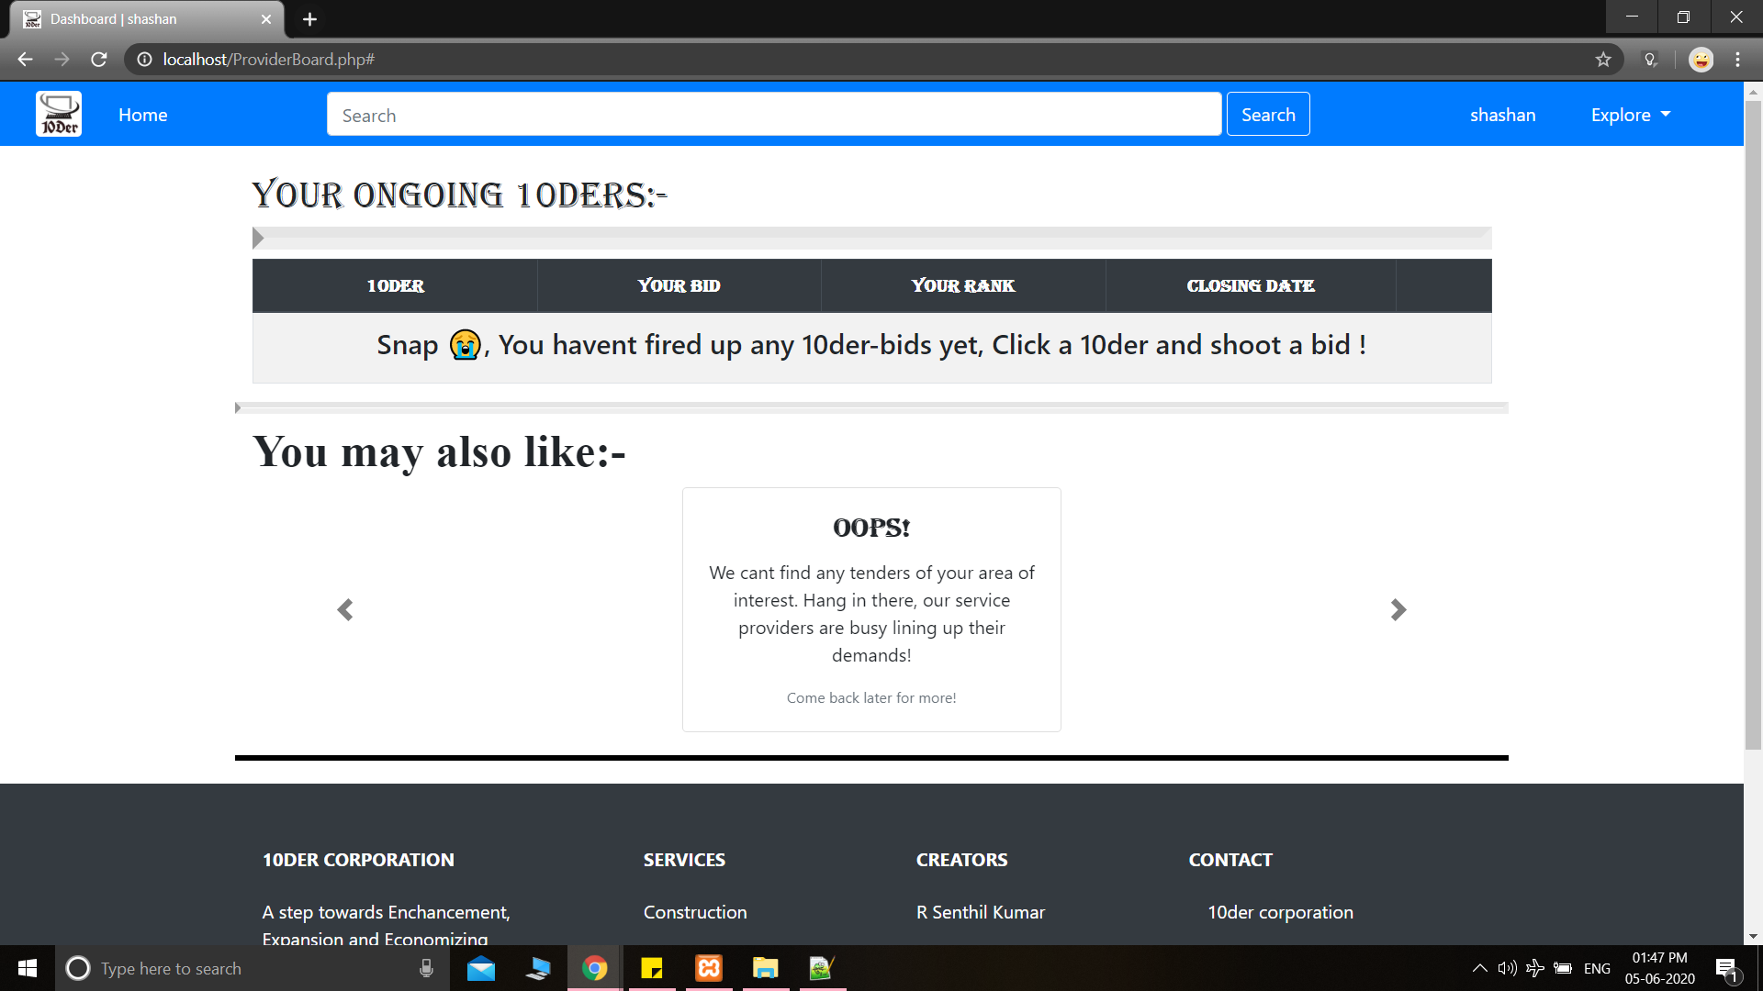

*Figure 16: Provider dashboard after sign-up*

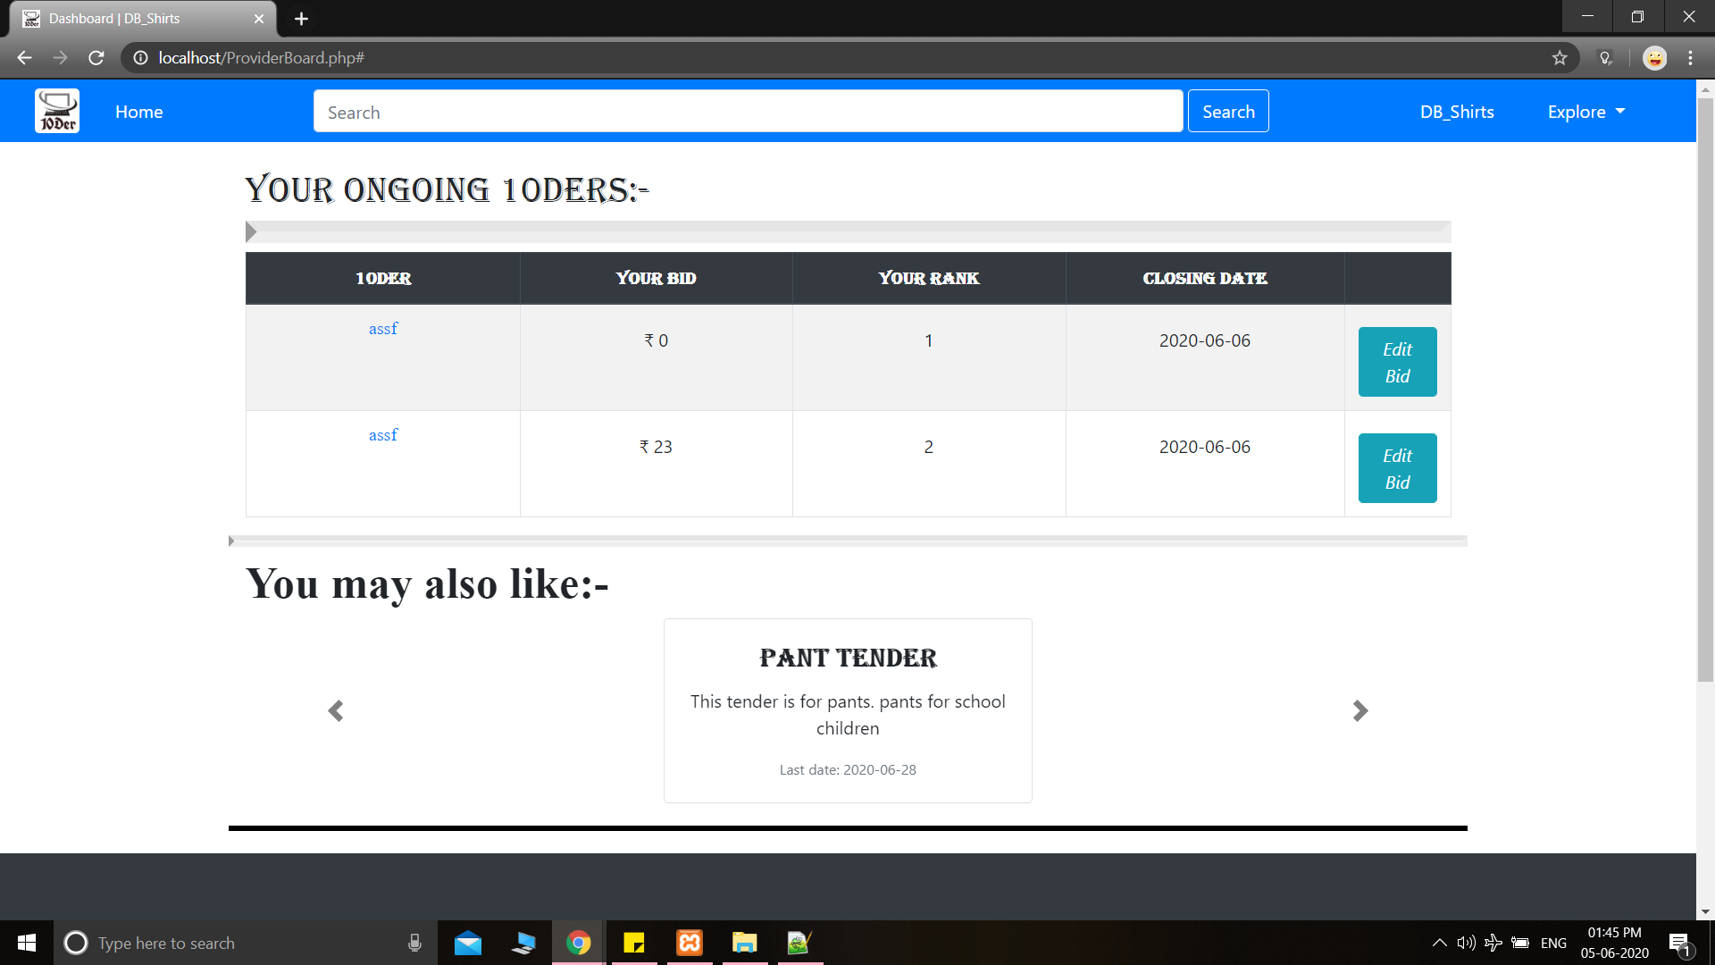

*Figure 17: Provider dashboard after placing bids*

**PHP CODE:**

**[ Note:** the multi-line-code is reduced to one-line-code in order to remove unnecessary tabs and newlines for documentation. Only the PHP code is included, HTML-CSS code is ignored in order to improve readability. **]**

**//login.php code:**

//////////////for signup////////////////////// if(isset($_POST['sign_up'])) { $user=$_POST['sname']; $email=$_POST['semail']; $password=$_POST['spassword']; $cpassword=$_POST['scpassword']; $mobile=$_POST['smobileno']; $category=$_POST['category']; $pass= password_hash($password, PASSWORD_BCRYPT); $cpass= password_hash($cpassword, PASSWORD_BCRYPT); $userquery="select * from $category where username='$user'"; $count=$conn->query($userquery); if($count->num_rows>0) { echo "<script>alert('username already taken')</script>"; } else { if($password===$cpassword) { $insertquery="INSERT INTO $category(username,password, mobile, email) VALUES ('$user','$pass','$mobile','$email')"; $iquery=$conn->query($insertquery); if($iquery) { echo "<script>alert('inserted successfully')</script>"; $_SESSION['user']=$user; #COOKIE EXPIRES IN 60*60 seconda= 1 Hour if($category=="requester") { header('Location: RequesterBoard.php'); } else { header('Location: ProviderBoard.php'); } } else { echo "<script>alert('error in insertion')</script>"; } } else { echo "<script>alert('password did not match')</script>"; } } } ///////////////////////for login////////////////////////// if(isset($_POST['login'])) { $luser=$_POST['lname']; $lpassword=$_POST['lpassword']; $query1="select * from requester where username='$luser'"; $query2="select * from provider where username='$luser'"; $result1=$conn->query($query1); $result2=$conn->query($query2); $count1=$result1->num_rows; $count2=$result2->num_rows; if ( $count1>0) { #echo "<script>alert('entered')</script>"; $email_pass = $result1->fetch_assoc(); $db_pass=$email_pass['password']; $pass_decode=password_verify($lpassword,$db_pass); if($pass_decode) { $_SESSION['user']=$luser; header('Location: RequesterBoard.php'); } else{ echo "<script>alert('Aww, snap! Your credentials might be incorrect, Try again!')</script>"; } } elseif ($count2>0) { $email_pass = $result2->fetch_assoc(); $db_pass=$email_pass['password']; $pass_decode=password_verify($lpassword, $db_pass); if($pass_decode) { #COOKIE EXPIRES IN 60*60 seconda= 1 Hour $_SESSION['user']=$luser; header('Location: ProviderBoard.php'); } else { echo "<script>alert('Aww, snap! Your credentials might be incorrect, Try again!')</script>"; } } else { echo "<script>alert('Aww, snap! Your credentials might be incorrect, Try again!')</script>"; } }

**//connection.php code:**

<?php $servername = "localhost"; $username = "root"; $password = ""; $dbname = "ver1"; // Create connection $conn = new mysqli($servername, $username,$password, $dbname); // Check connection if ($conn->connect_error) { die("Connection failed: " . $conn->connect_error); } #1$2y$10$R7V5UR8M0K8Rp #$2y$10$R7V5UR8M0K8Rp ?>

**//Logout.php code:**

<?php session_start(); session_unset(); session_destroy(); setcookie('user', '',time() - 3600); setcookie('category', '',time() - 3600); header('Location: 10DER.php'); ?>

**//ProviderBoard.php code:**

<?php $querypro='SELECT tender.title, tender.end, bid.bidder, bid.amount, RANK() OVER (PARTITION BY bid.tno ORDER BY bid.amount)rank FROM bid INNER JOIN tender ON tender.tno=bid.tno where 1 and bid.bidder="'.$user.'"'; $resultpro=$conn->query($querypro); if($resultpro===false||mysqli_num_rows($resultpro)==0) { echo '<tr> <td colspan="5"><h4 align="center"> Snap , You havent fired up any 10der-bids yet, Click a 10der and shoot a bid ! </h4></td> </tr>'; } else { while($rowpro = $resultpro -> fetch_assoc()) { echo '<tr> <td><a href="#" style="font-family: Source Sans Pro">'.$rowpro["title"].'</a></td> <td style="padding-top: 20px">₹ '.$rowpro["amount"].'</td> <td style="padding-top: 20px">'.$rowpro["rank"].'</td> <td style="padding-top: 20px">'.$rowpro["end"].'</td> <td style="padding-top: 20px"><button type="button" class="btn btn-info"><i>Edit Bid</i></button></td> </tr>'; } } ?>

**//RequesterBoard.php code:**

<?php if(!isset($_SESSION)) { session_start(); } //IF USER DID NOT LOGIN IN LOCAL SYSTEM if(!$_SESSION['user'] or $_SESSION['user']=='none') header('location: login.php'); include("connection.php"); setcookie ("user",$_SESSION['user'],time()+ 3600); setcookie ("category","requester",time()+ 3600); include("tender_create.php"); ?> <?php //PART A: TENDER TITLE OBTAINER $query="select tno,title,start,status from tender where creator='".$_SESSION['user']."' and 1 order by status desc"; $result=$conn->query($query); if($result===false||mysqli_num_rows ( $result)==0) { echo '<br><br><h4 align="center"> Oops! You havent fired up any 10ders yet! Press the "new" button to create one! </h4>'; } else { while($row = $result -> fetch_assoc()) { echo '<br>'; echo '<h4 align="left"> #T'.$row['tno'].': '.$row['title'].'</h4>'; $v=date_create($row['start']); $vv=date_create(); #echo $v,$vv; //PART B: TENDER BID OBTAINER if($row['status']==0) { echo '<ul style="list-style: none;" ><li><div class="bid"> <span class="subject" style="color:#333333;"><i>This tender has been <b>closed</b>.</i></span> <button class="kn" style="background-color: #222222; margin-right: 0px;position:relative;bottom:5px;" onclick="location.href =\'tender_info.php?tno='.$row['tno'].'\';"> ⓘ <i>Know more </i></button> </div></li></ul><br><br>'; } else if($vv<$v) { echo '<ul style="list-style: none;" ><li><div class="bid"> <span class="subject" style="color:#333333;"><i>This tender will go live in <b style="color: #8E44AD;">'.date_diff($vv,$v)->format("%R%a days").' </b>.</i></span> <button class="kn" style="background-color: #8E44AD; margin-right: 0px;position:relative;bottom:5px;" onclick="location.href =\'tender_info.php?tno='.$row['tno'].'\';"> ⓘ <i>Know more </i></button> </div></li></ul><br><br>'; } else { //echo '<ul style="list-style: none;" >'; $querysub="select * from bid where 1 and tno=".$row['tno']." ORDER BY amount ASC "; $resultsub=$conn->query($querysub); if($resultsub===false||mysqli_num_rows($resultsub)==0) { echo '<ul style="list-style: none;" ><li><div class="bid"> <span class="subject" style="color:#333333;" ><i>Nobody has bidded yet. <b style="color: #008800">Good things take time!</b></i></span> <button class="kn" style="background-color: #00AA55; margin-right: 0px;position:relative;bottom:5px;" onclick="location.href = \'tender_info.php?tno='.$row['tno'].'\';"> ⓘ <i>Know more </i></button> </div></li></ul><br><br>'; } else { echo '<ul style="list-style: none;" >'; while($rowsub = $resultsub -> fetch_assoc()) { echo '<li><div class="bid"><b><span class="sellerid">'.$rowsub['bidder'].'</span><span style="font-size: large;"> :- </span> <span class="price">₹'.$rowsub['amount'].'</span></b><br> <span class="subject" style="color: #333333;"><b>'.$rowsub['subject'].'</b></span> <span class="description"><i>'.$rowsub['description'].'</i></span> <button class="kn"> ⓘ <i>Know more </i></button> <button class="procure"><i> ✔ Procure </i></button> <button class="shortlist" style="background-color: #FFA320;"><i> ⧖ shortlist </i></button> </div> </li>'; } echo '</ul><br><br>'; } //echo '</ul><br><br>'; } } } ?>

**//tender_create.php code:**

<?php if(!isset($_SESSION)) { session_start(); } include("connection.php"); if(isset($_POST['title'])&&isset($_SESSION['user'])&&($_SESSION['user']!='none')) { $title=$_POST['title']; $aoi=substr($_POST['categ'],0,3); $start=$_POST['start']; $end=$_POST['end']; $status=1; $creator=$_SESSION['user']; $description=$_POST['description']; $tandc=$_POST['tandc']; if($start==""||$start=="0000-00-00") { ; } else { $v=date_create($end); $vv=date_create(); if($vv>$v) $status=0; $sql = "INSERT INTO tender (title, aoi, start, end, status, creator, description,tandc) VALUES ('".$title."','".$aoi."','".$start."','".$end."',".$status.",'".$creator."','".$description."','".$tandc."')"; echo $sql; if ($conn->query($sql) === TRUE) echo "yes"; else echo "Error: " . $sql . "<br>" . $conn->error; } } ?>

**//10DER.php code:**

<?php session_start();include("connection.php"); ?> <?php if(!$_SESSION['user'] or $_SESSION['user']=='none'){echo "10DER.php";}else{echo "RequesterBoard.php";}?>"><?php if(!$_SESSION['user'] or $_SESSION['user']=='none'){echo "Home";}else{echo $_SESSION['user'];}?> <?php if(!$_SESSION['user'] or $_SESSION['user']=='none'){echo "href='.\login.php'";}else{echo "href='.\logout.php'";}?> > <?php if(!$_SESSION['user'] or $_SESSION['user']=='none'){echo "Login";}else{echo "Logout";}?>

**CONCLUSION**

Using PHP and its core features as the baseline, we have developed a ***fully-functioning, stable, dynamic and DB-integrated 10DER.com website***. Through this project, we had several learning outcomes, such as web-design, PHP, Backend-Frontend integration, MySQL basics and full-stack web development. We also hope to implement this project on a larger scale by proposing it to government and private concerns, because we work for:

*“... a brighter tomorrow!”*